**Spring 2017**

**ESI 5359**

**Industrial Financial Decisions**

**Yezehao Huai (5965823)**

**Chapter 9 Homework**

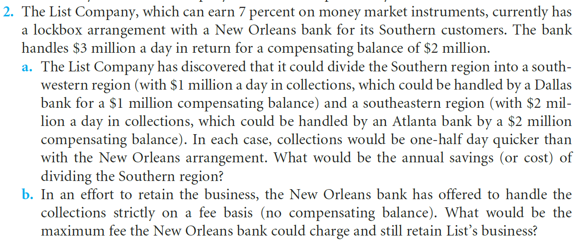

1. Saved in collections is $3 million * 0.5=$1.5 million

Increased balance is $2 million + $1 million - $2 million =$1 million

So the net saving is $0.5 million

Annual savings is $0.5 million * 7%=$35,000

1. $2 million * 7%=$140,000

$140,000-$35,000=$105,000

So the maximum fee New Orleans bank could charge is $105,000

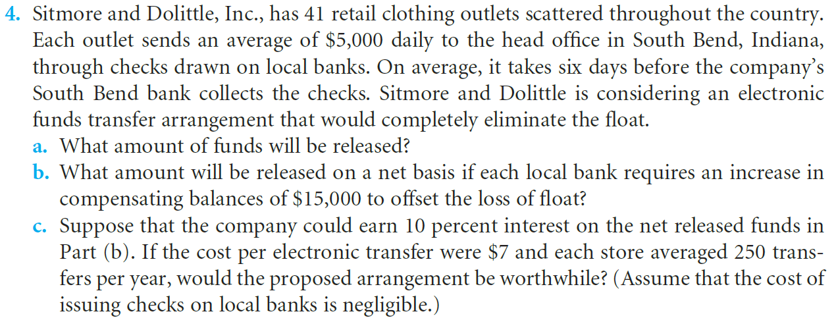

1. 41*$5,000*6 = $1,230,000
2. $1,230,000-$15,000*41

=$1,230,000-$615,000

=$615,000

1. Earned from interest is $615,000*10%=$61,500,

Total cost by electronic transfer is 250*41*$7=$71,750, higher than earned from interest.

So this proposed arrangement would not be worthwhile.